**TASK-1: Data Overview**

Objective: Understand the dataset structure.

Steps:

1. Load the dataset: Import the dataset into a data analysis tool such as Python with pandas or spreadsheet software.
2. Descriptive Statistics: Use descriptive functions (e.g., info() in pandas) to gather information about the number of entries, columns, and data types.

Python Code:

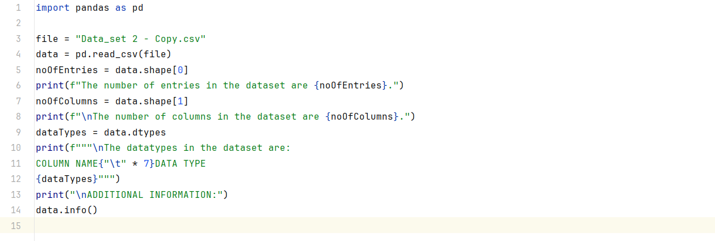

Output:

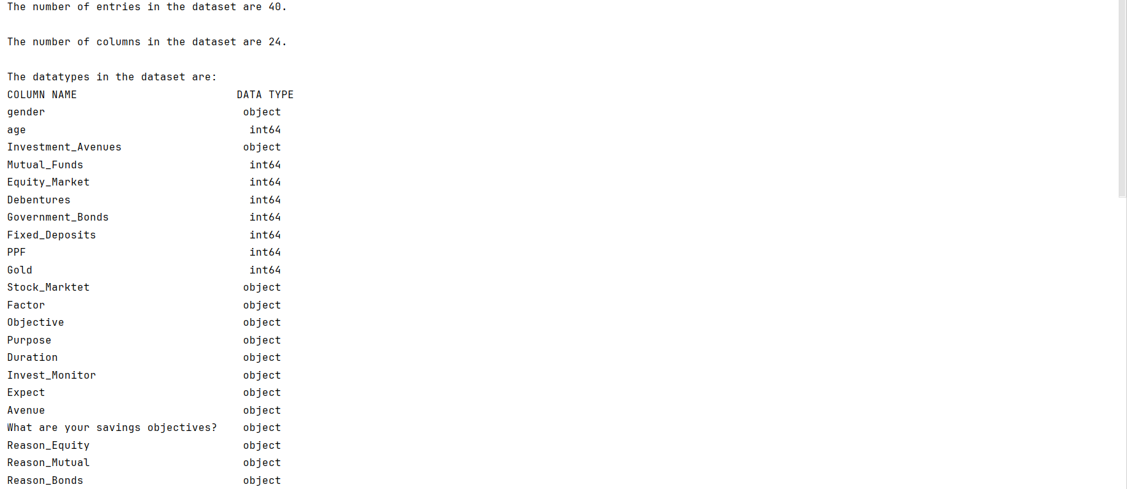

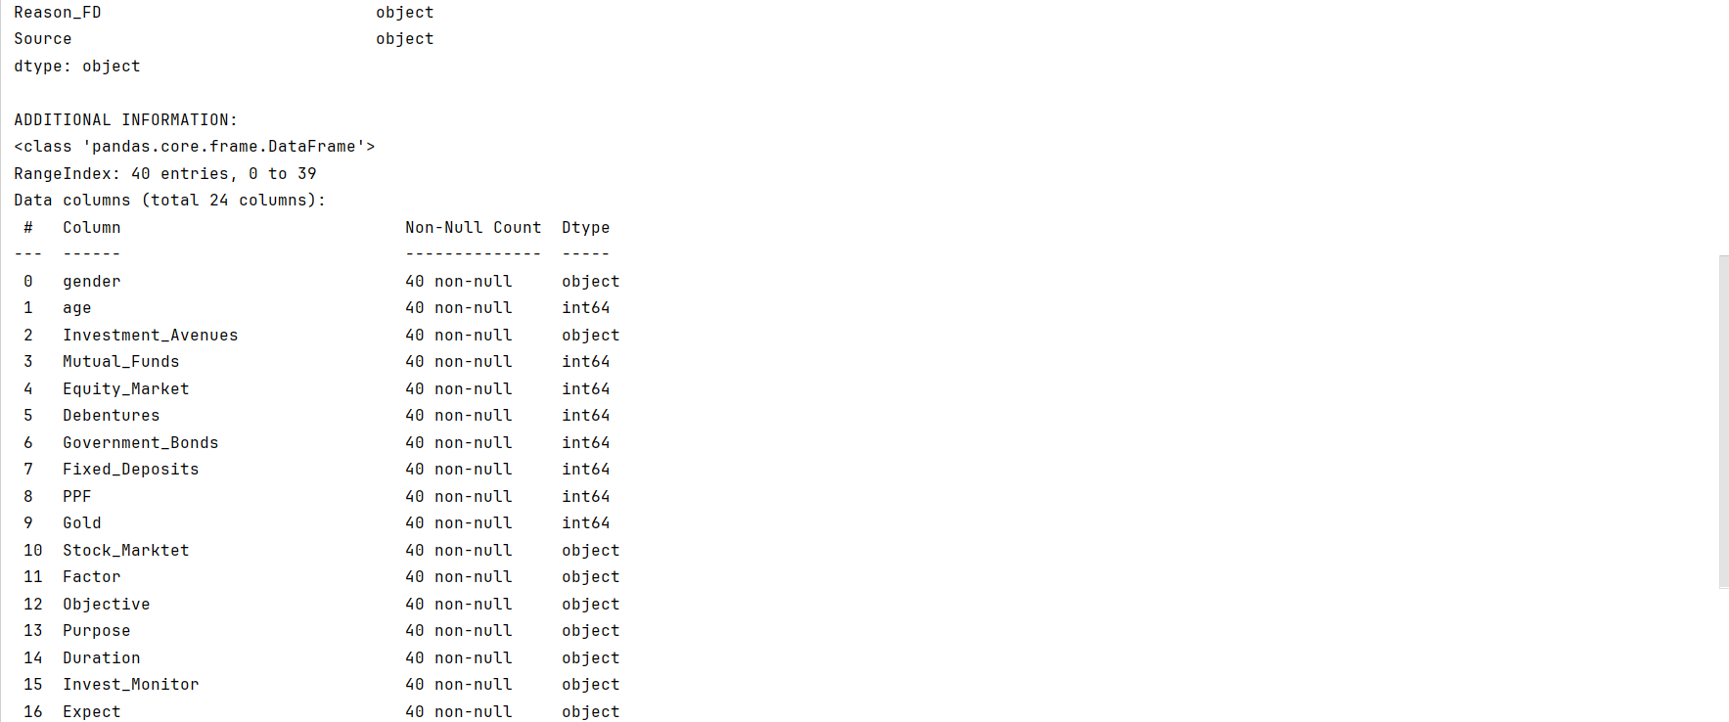

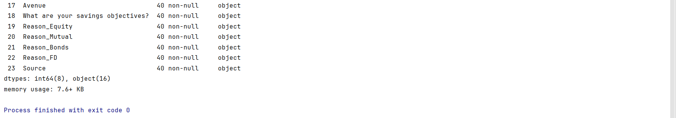

**TASK-2: Gender Distribution**

Objective: Visualize gender distribution in the dataset.

Steps:

1. Extract Gender Information: Identify and extract the gender column from the dataset.
2. Visualization: Create a simple visualization, such as a bar chart or pie chart, to represent the distribution of genders in the dataset.

Python Code:

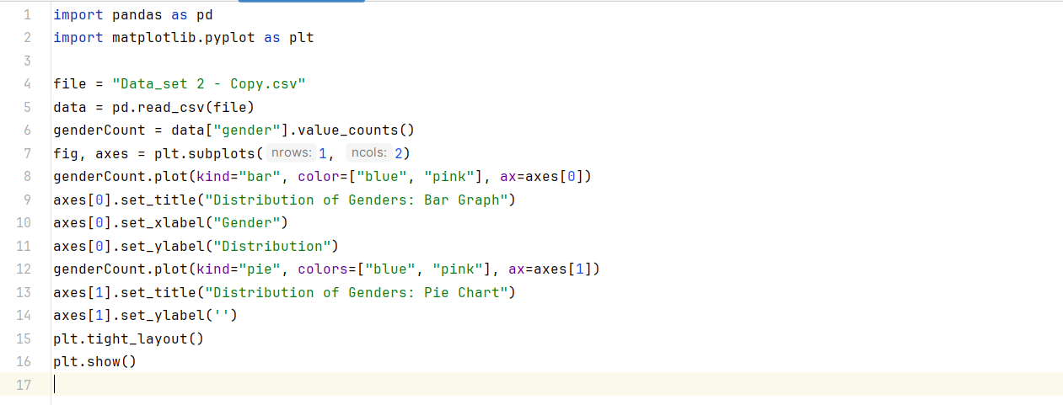

Output:

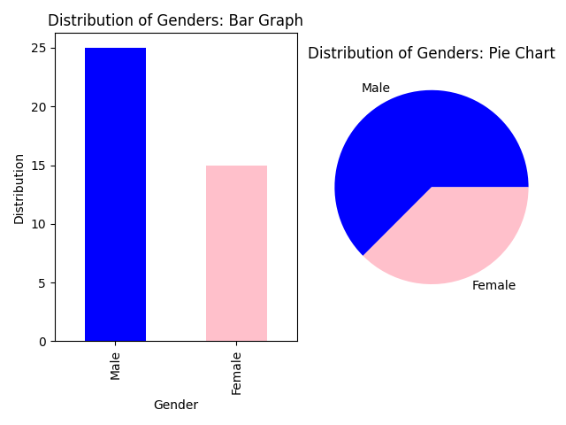

**TASK-3: Descriptive Statistics**

Objective: Present basic statistics for numerical columns.

Steps:

1. Identify Numerical Columns: Review the dataset to identify columns containing numerical data (e.g., age, income).
2. Calculations: Use statistical functions (e.g., mean(), median(), std()) to calculate the mean, median, and standard deviation for each numerical column.

Python Code:

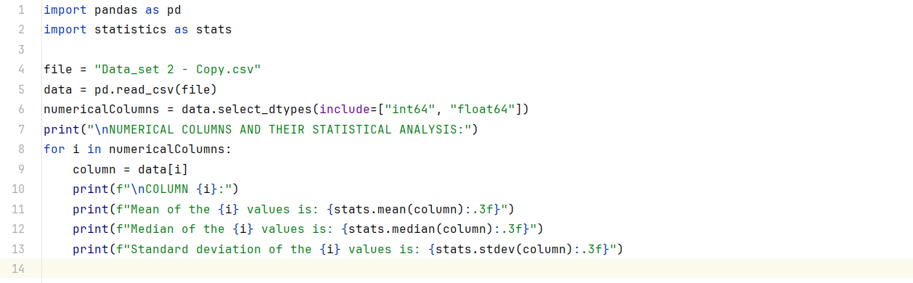

Output:

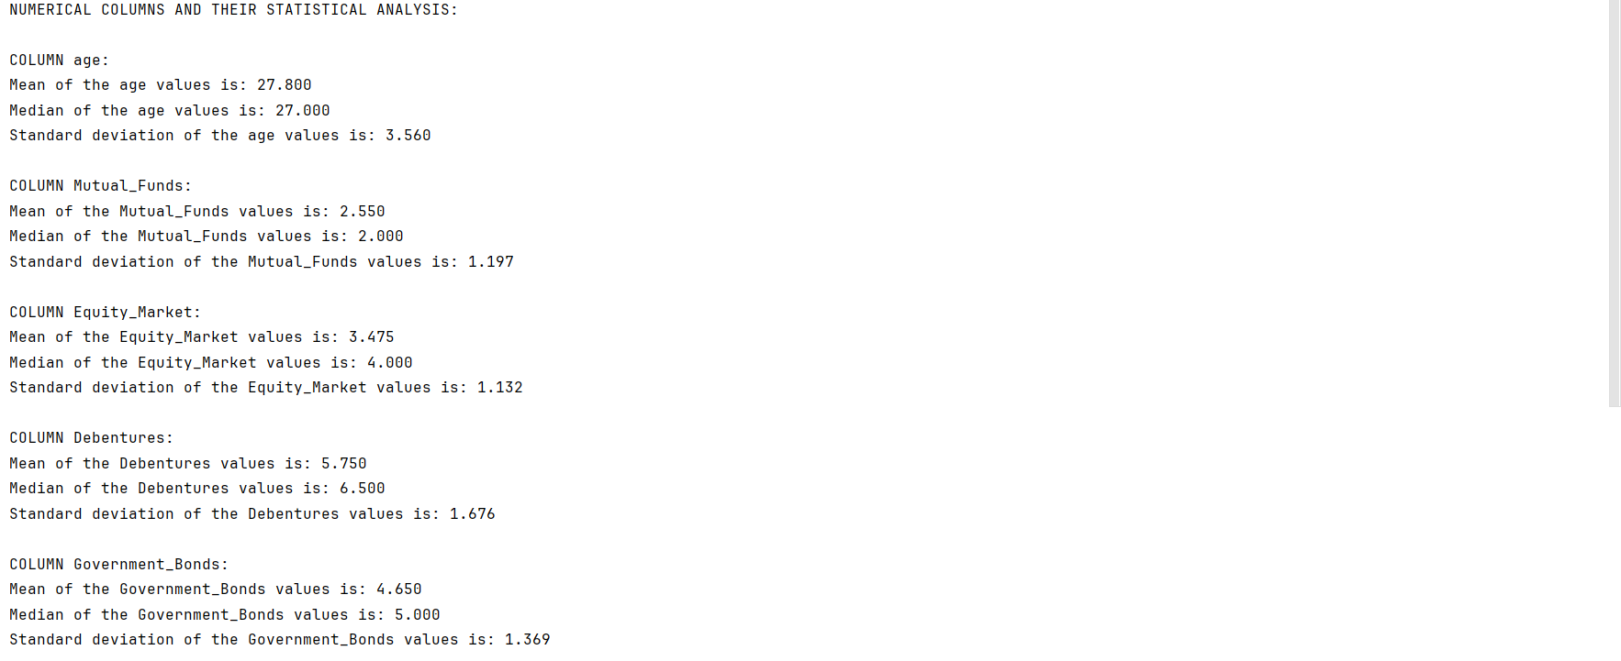

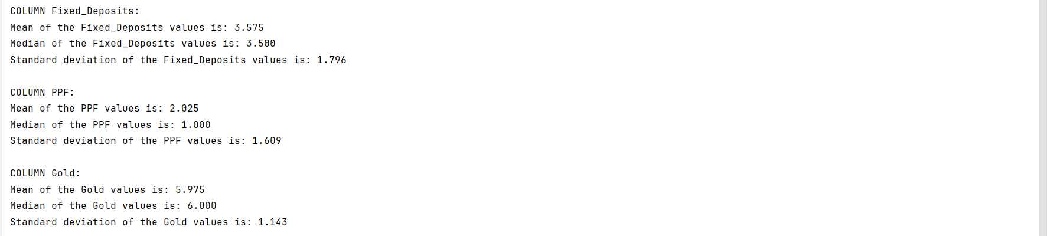

**TASK-4: Most Preferred Investment Avenue**

Objective: Identify the most preferred investment avenue.

Steps:

1. Analyse Investment Avenues: Examine the column containing information about different investment avenues (e.g., equity, mutual funds).
2. Frequency Analysis: Determine the investment avenue with the highest frequency or occurrence.

Python Code:

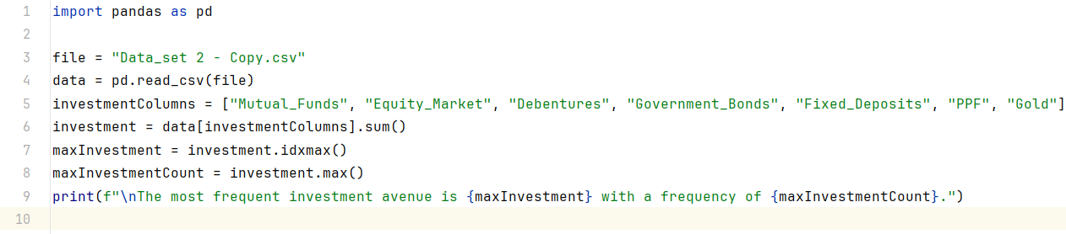

Output:



**TASK-5: Reasons for Investment**

Objective: Analyse and summarize reasons for investment choices.

Steps:

1. Explore Reasons Column: Investigate the column where participants provided reasons for their investment choices.
2. Summarize Reasons: Identify common themes or recurring reasons and provide a summary.

Python Code:

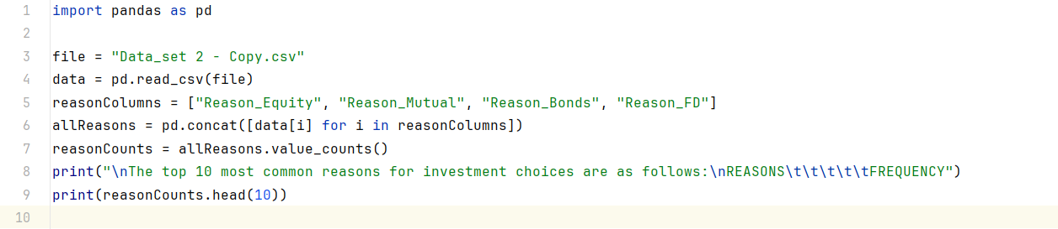

Output:

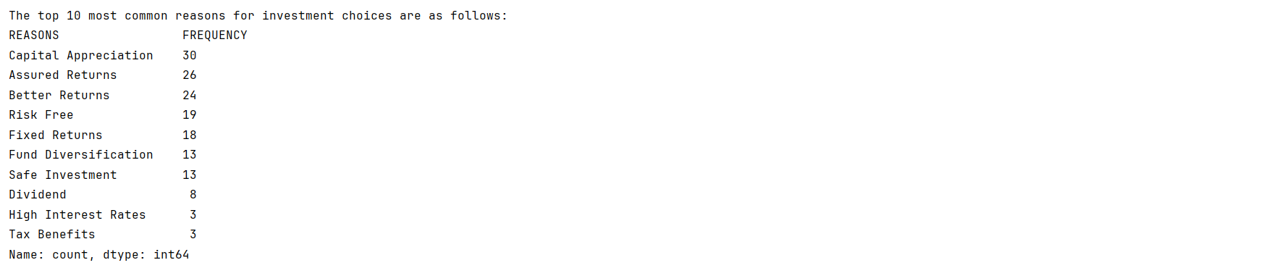

**TASK-6: Savings Objectives**

Objective: Identify and present main savings objectives.

Steps:

1. Analyse Savings Objectives: Examine the column containing information about participants' savings objectives.
2. List and Describe Objectives: Create a list and describe the main savings objectives mentioned by participants.

Python Code:

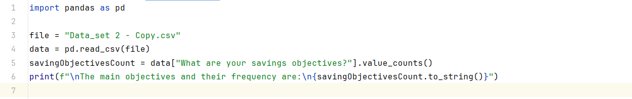

Output:

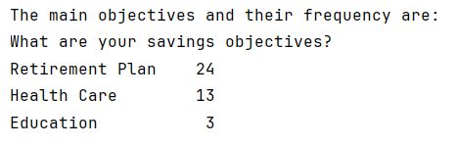

**TASK-7: Common Information Sources**

Objective: Analyse common sources participants rely on for investment information.

Steps:

1. Explore Information Sources Column: Review the column where participants indicated their sources of investment information.
2. Identify Common Sources: Analyse the data to identify and summarize the most common sources participants rely on.

Python Code:

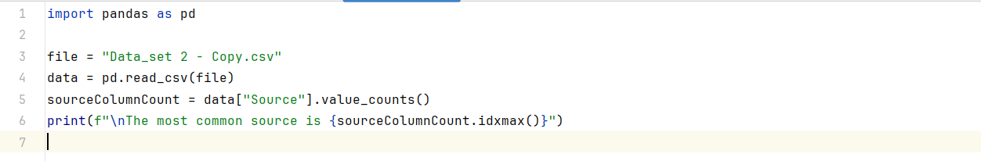

Output:



**TASK-8: Investment Duration**

Objective: Calculate the average investment duration.

Steps:

1. Analyse Investment Duration Column: Examine the column containing information about participants' investment durations.
2. Calculate Average Duration: Use appropriate statistical methods to calculate the average investment duration.

Python Code:

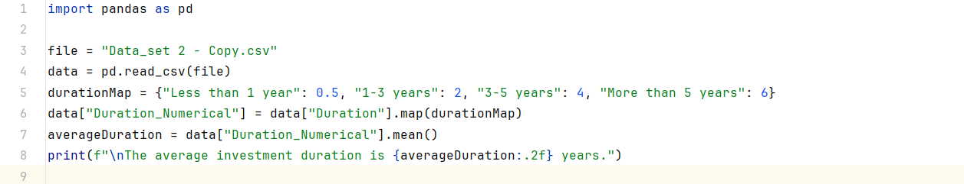

Output:



**TASK-9: Expectations from Investments**

Objective: Summarize participants' expectations from investments.

Steps:

1. Explore Expectations Column: Review the column where participants provided information about their expectations.
2. List and Describe Expectations: Create a list and describe the common expectations mentioned by participants.

Python Code:

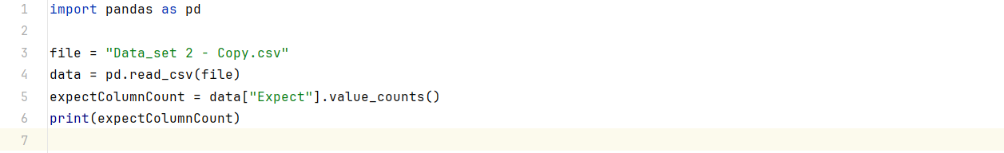

Output:

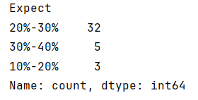

**TASK-10: Correlation Analysis**

Objective: Explore potential correlations between factors.

Steps:

1. Select Relevant Columns: Identify columns such as age, investment duration, and expected returns for correlation analysis.
2. Use Statistical Methods or Visualizations: Employ statistical methods (e.g., correlation coefficients) or visualizations (e.g., scatter plots) to explore and visualize potential correlations.

Python Code:

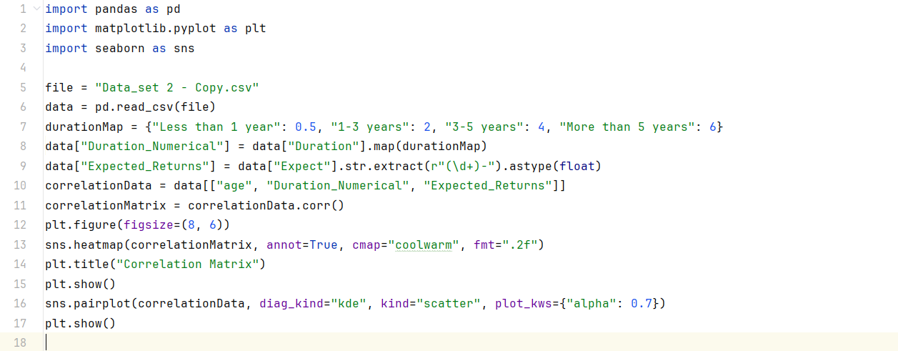

Output:

